Experiment 2 N.sri vara deepak
8- Queen Problem 192572075
Aim
To solve the 8-Queen problem using Python Program.
Algorithm
Start.
Create an empty 8 × 8 chessboard.
Begin placing queens from the first column.
For each row in the current column:
- Check whether placing a queen is safe.
- A position is safe if:
  - No queen exists in the same row on the left.
  - No queen exists on the upper-left diagonal.
  - No queen exists on the lower-left diagonal.
If the position is safe:
- Place the queen.
- Recursively move to the next column.
If all 8 columns are filled:
- A valid solution is found.
- Print the board and stop.
If no safe position is found in the current column:
- Remove the previously placed queen (backtracking).
- Try the next possible row.
If all rows in the first column have been tried and no solution is found:
- Print "No solution exists."
Program
N = 8
board = [[0] * N for _ in range(N)]
def is_safe(row, col):
# Check same row on the left side
for i in range(col):
if board[row][i] == 1:
return False

# Check upper-left diagonal
i, j = row, col
while i >= 0 and j >= 0:
if board[i][j] == 1:
return False
i -= 1
j -= 1

# Check lower-left diagonal
i, j = row, col
while i < N and j >= 0:
if board[i][j] == 1:
return False
i += 1
j -= 1

return True

def solve(col):
if col == N:
return True

for row in range(N):
if is_safe(row, col):
board[row][col] = 1

if solve(col + 1):
return True

board[row][col] = 0

return False
if solve(0):
print("Solution:")
for row in board:
print(*["Q" if x else "." for x in row])
else:
print("No solution exists.")

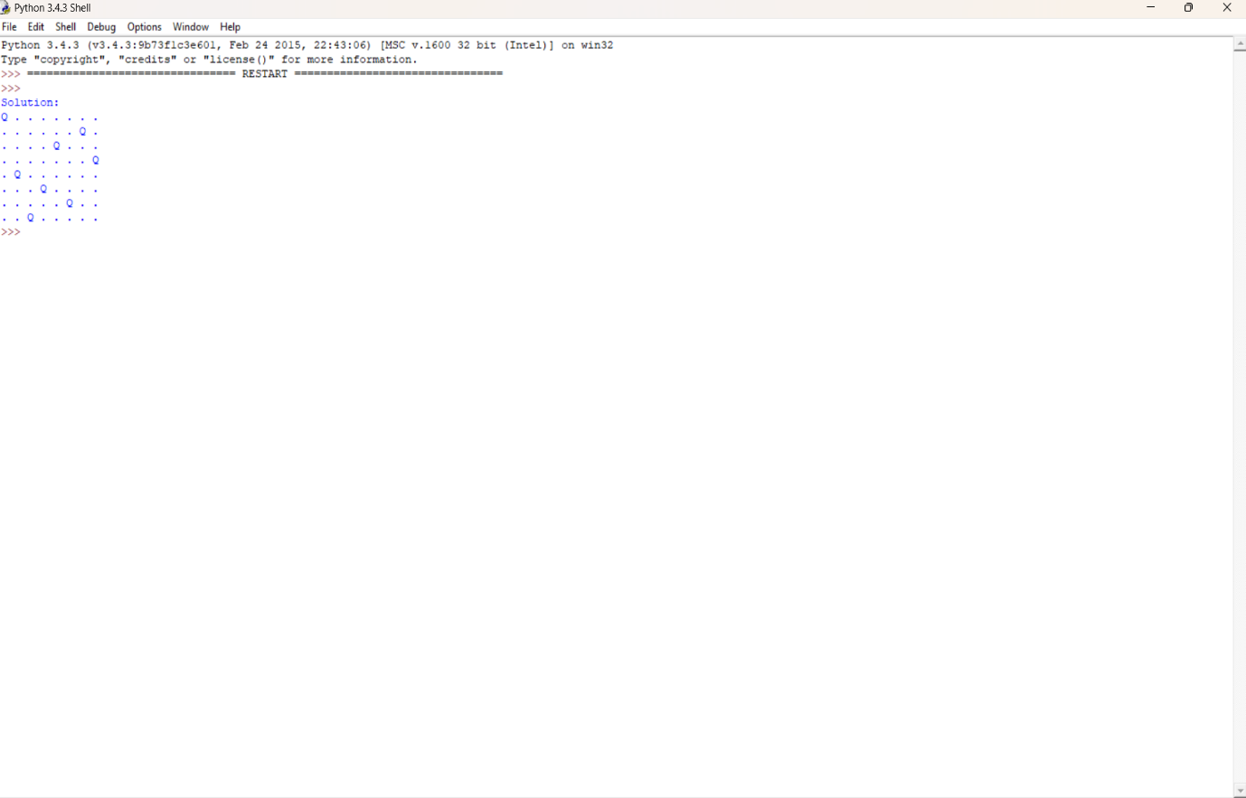
Output

Result
The 8-queen program was executed successfully. It accepted the user input, checked the puzzle state, and displayed whether the puzzle could be solved in one move

